Deimos ECO Harnesses (Climber Style)
These harnesses are designed for rope parks that have challenge courses, zip lines rides, as well as drop towers and king swings.
ECO Sit  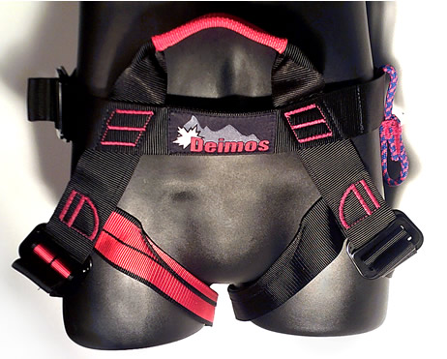 | Designed rope parks and zip lines:  - Light full body harness. Very easy to walk in.  - One Size fits all!  - Waist Size (up to 52” 132 cm).  - Rider Age: 8 and up.  - No rear D-Ring.  - Certification: EN 12277  - Tested to more than 4000lbs.  - Weight: 430g.  - Size (XS-XL)  Impact Force  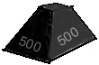
ECO K-Lite  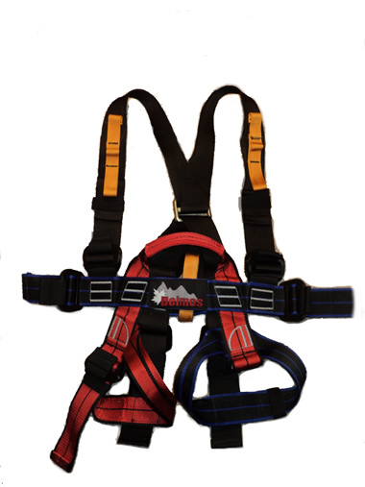 | Designed rope parks and zip lines:  - Light full body harness for small children. Very easy to walk in.  - Waist Size (58 to 90 cm).  - Leg Size (31-56 cm).  - Max height (145cm).  - Rider Age: 4-11.  - Has Rear D-Ring.  - Certification: UIAA105  - Tested to more than 4000lbs.  - Weight: 500g  - Size (XS-S).  Impact Force

ECO Lite  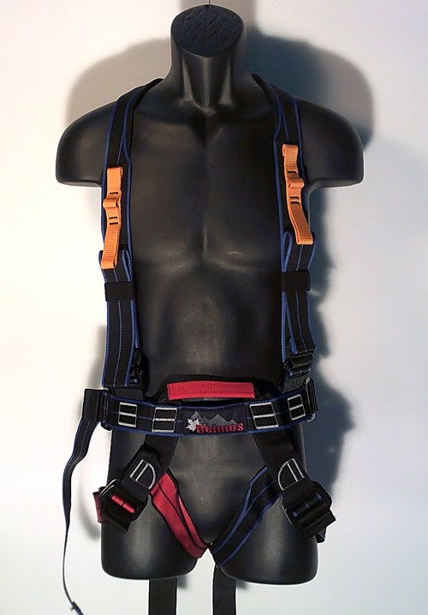 | Designed for rope parks and zip lines:  - Light full body harness, very easy to walk in.  - Available in one size only.  - Waist Size (61 – 147 cm).  - Rider Age: 8 and up.  - Has rear D-Ring.  - Certification: UIAA105.  - Tested to breaking force of 6362 lbs.  - Tested to more than 4000lbs.  - Weight: 600g  - Size (S-XL)  Impact Force
ECO Lite III  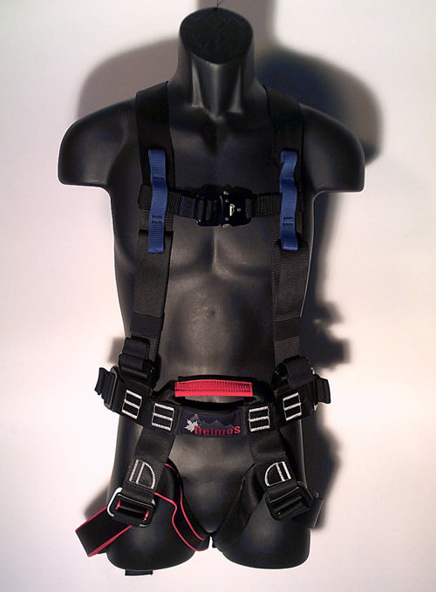 | Designed for rope parks and zip lines:  - Light full body harness, very easy to walk in.  - Available in one size only (S-XXL).  - Waist Size (61 cm to 147 cm).  - Rider Age: 8 and up.  - Has rear a D-Ring.  - Certification: EN 813 358 361  (feet first and heads first tested).  - Tested to more than 4000lbs.  - Weight: 600g  - Size (S-XL)  Impact Force

ECO 5000  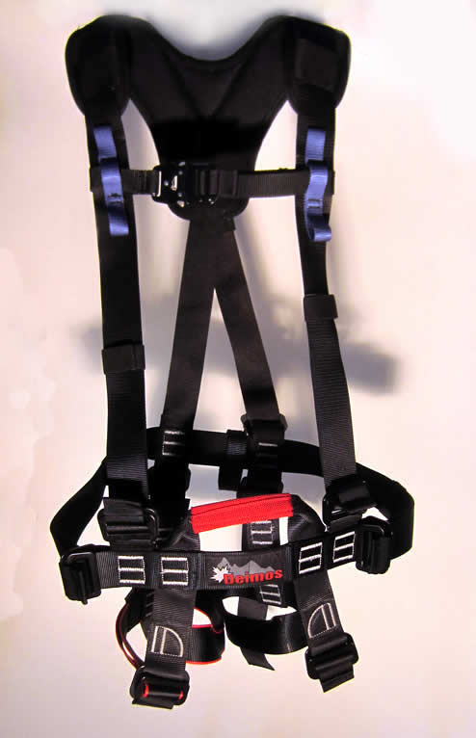 | Designed for both rope parks and zip lines.  - Medium weight, full body harness for use in adventure parks. Fully padded shoulder straps.  - Available in one size only (S-XXL)  - Waist Size (61 cm to 147 cm).  - Rider Age: 8 and up.  - Has no rear D-Ring or leg padding.  - Certification: EN 12277  - Feet first and heads first tested.  - Tested to more than 5000lbs.  - Weight: 800g  - Size (S-XL)  Max Impact Force
ECO D-Lite (S) and (L)  (rear view)  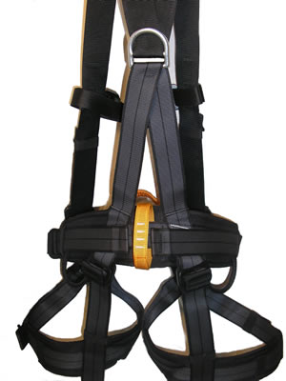 | Designed for both rope parks and zip lines.  - Medium weight, full body harness for use in adventure parks. Fully padded legs and waist straps.  - Two large gear Loops  - Certifications: CE 1019 , EN 12277  - Tested to more than 4000lbs.  - Weight: 850g and 900g  Available in two sizes:  - S (83 – 135 cm) Small Waist Padding  - L (94 – 145 cm) Large Waist Padding  Max Impact Force

ECO Pro  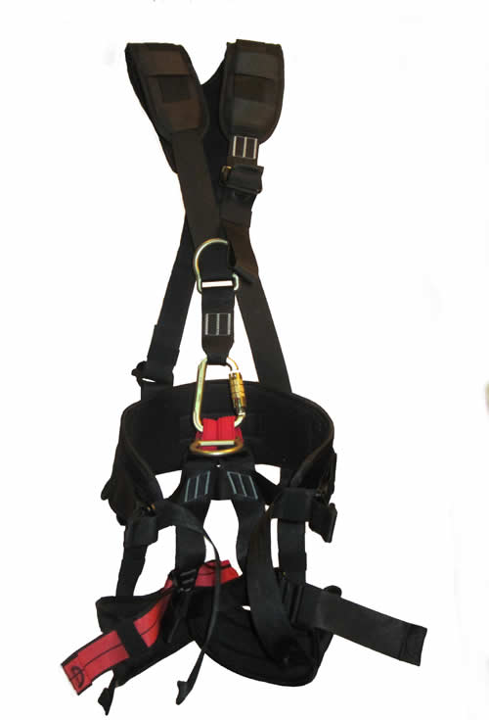 | Designed for Leap Towers and Ziplines:  - A fully padded full body harness designed especially for Leap Towers. No quick release buckles.  - Available in two sizes  - Three tie in points  - Two large gear loops  - Includes 50kN locking carabiner  - Certifications: EN361, 358, 813  - Tested to more than 4000lbs.  - Weight: 2223g >4000 lbs  - Size (XS-M) – (58 – 111cm)  - Size M-XL – (78 – 142cm)  Max Impact Force
FreeStyle GM  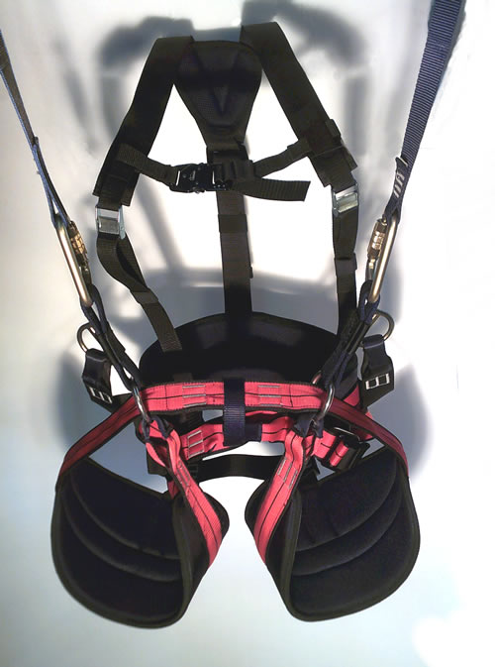 |  | Function: climb and zip.  Easy to walk in – the best option for course with lots of walking and long zip lines.  One harness for both rope parks and dual zip lines.  Works with all trolley types.  Available in three sizes :  XS-M Waist 22” to 44”  M-XL Waist 27” to 51”  L - XXL Waist 27” to 54”  Function: Full chair zip or climbing harness.  Weight – around 1.5 kg  Certified EN 1651  Front loop tested to more than 5800 lbs!  Max Impact Force

WallTee  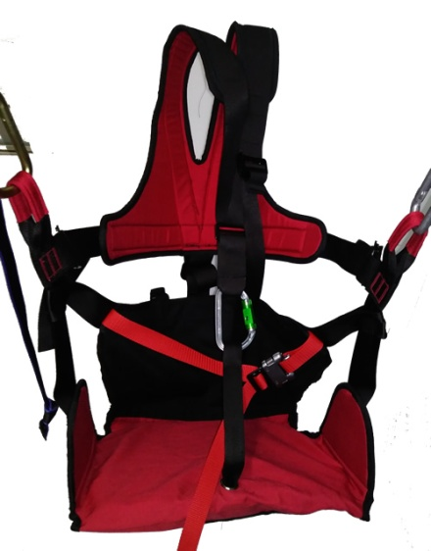 | Function: Zip Lines only.  Highest comfort – has padded wooden seat.  Spreader bar required.  Available in three sizes :  (XS-M) Rider’s age 2-11.  (S-L) Rider’s age 8 and up.  (L- XXL) For Rider’s 220 to 300 lbs!  Function: ZipLine Chair.  Weight – around 2.5 kg  Size S-L - Certified EN 1651  Others sizes have not been tested yet.  Tested to more than 4000 lbs!  Max Impact Force

Impact Force Indicator

This is a general indication of how comfortable the harness will feel if you take a fall. Typically all harnesses are tested and certified to at least 4000 lbs.

Not comfortable if you fall (for high walk ways).
Has extra webbing in seat for comfort (for ziplines).
has padded legs and waist (for challenge courses and ziplines).
Designed for big falls (for tower leaps and ziplines).

